

Go-To-Market Plan Document
OneMedia

Document Number: GTM2010-003
Revision 1

Prepared by:
Rajen Shah

INTERNAL USE ONLY DOCUMENT. This document shall be distributed to Panasonic Avionics Corporation personnel only. ISM policies for Internal Use Only documents for storage, transport, and workspace environment are to be observed.
Table of Contents

1 MARKETING 3
1.1 Brief Product Description 3
1.2 Tagline 3
1.3 Press Release Copy 3
1.4 Top Features and Benefits 3
1.5 Value Propositions (Marketecture) 3
1.6 Position Statements 4
1.7 External FAQs 4
1.8 Market Analysis 5
1.8.1 Target Audience 5
1.8.2 Competitive Comparison 5
1.8.3 SWOT Analysis 6
1.9 Communication and Training Plan 7
2 SALES TOOLS 7
2.1 Estimated Availability ODD 7
2.2 Pricing 7
2.3 Internal FAQs 7
3 PROPOSAL INFO 9
3.1 Description 9
3.2 Value Proposition 9
3.3 Feature and Functionality 10
3.4 Part Number and Description 11
4 Revision History 12

MARKETING

Brief Product Description
OneMedia is an attractive software service that transforms an in-flight entertainment (IFE) system into a unique advertising platform designed to generate ancillary revenue for the airlines.

Tagline
Serve advertisements within IFE and generate ancillary revenue for an airline.

Press Release Copy
- 25 Word Copy
OneMedia provides attractive advertising medium to generate recurring ancillary revenue for an airline.

- 50 Word Copy
OneMedia transforms IFE into an attractive advertising medium giving advertisers access to a large captive audience while generating recurring ancillary revenue for an airline. OneMedia also provides the Magazine Rack with branded content publications through interactive to enhance passenger experience.

Top Features and Benefits
Features | Benefits
Serve various formats of advertisements within airline interactive and Magazine Rack  - Banners  - Interstitial  - Rich media  - Micro site | Provides recurring ancillary revenue stream for airlines having advertisers reach on-board passengers
Logs impression, click-through and data acquisitions | Logging enables generation of industry standard reports for publisher/ad agency and airline
Enables campaign management  - Target advertisements based on destinations, time, cabin class, language, and category  - Flexibility to approve or reject advertising campaigns | Campaign management enables publisher/ad agency to create/modify campaigns based on specific targeting criteria and also enables to review campaigns by airline
Manage Micro site and branded Magazine content using Content Publishing Tool | Content Publishing Tool enables quick turn around for integration and update of new magazines and micro site
Familiar and timely reports of impressions, click-through, data acquisition, campaign and advertiser | Reports enable publisher/ad agency to measure the success of campaign, track revenue and plan future advertisement sales
Leverage a familiar internet-style advertising guidelines | Enables publisher/ad agency to utilize existing campaign creative used on Internet today inside IFE
Interface with ERP | Automatically generates PO/Invoice based on revenue reports

Value Propositions (Marketecture)
Generates ancillary revenue from IFE advertising at a very low incremental cost to the airline.
Under OneMedia revenue share model,
- Airline can generate between 40 % to 75% of advertising revenue.
- Content and advertising serving software is provided to an airline at no cost.
- Airline only pays for connectivity usage fees or for manual process of uploading the content or offloading the usage.
Extends IFE to utilize well known Internet advertising standards.
- Built upon familiar guidelines (such as sizes and formats) specified by Interactive Advertising Bureau (www.iab.net). These advertising guidelines are well known in today’s internet industry.
- Enables the utilization of existing internet advertising sales channel methodology.
Easy and convenient way of updating advertisements.
- Manages ad campaigns without requiring CR/ATP.
- Advertisements can uploaded to the aircraft anytime if connectivity (cell modem or braodband) is present.
Provides weight saving solution to airlines and reduces paper in the cabin.
- Digitized magazine content
- Periodic magazine updates
- Helps save airlines the replacement costs of physical magazines

Position Statements
OneMedia is the advertising engine and primary ancillary revenue generating application for Panasonic’s in-flight entertainment (IFE).

External FAQs
Q: What is OneMedia?
A: OneMedia is an attractive software service that transforms an in-flight entertainment (IFE) system into a unique advertising platform that generates recurring ancillary revenue for an airline.
Q: What stage of development is it in?
A: OneMedia is under development.
Q: What airlines are interested?
A: List of airline interested are Delta, Lufthansa, U.S. Airways, Air Austral, Garuda, Etihad, Egypt Air, Hawiian, Phillipine Air, Eva, Malaysian Air, TACA, Tap Portugal, and Jet Airways.
Q: When will it be available?
A: OneMedia will be available on June 18th, 2010.
Q: On which aircraft platform is made for?
A: OneMedia is available on Panasonic’s X and S3K series platforms.
Q: What is special about OneMedia?
A: Panasonic’s OneMedia service provides both the on-board ad-serving software and the ground-based infrastructure for airlines. It generates ancillary revenue through targeted, regularly updated advertising displayed on Panasonic in-flight entertainment systems. It also reduces weight through frequently updated branded and digtized magazine content.
Q: Is it Boeing and Airbus line-fit offerable?
A: Yes.

Market Analysis

Target Audience
Market Segments
OneMedia would most likely be a primary candidate for non-premium and non-super premium airlines with in-seat In-Fight Entertainment (IFE).

- Target Audience
Primary target audiences for OneMedia is
- Airlines whose primary focus is ancillary revenue
- Airlines with Panasonic’s X series and S3K Systems

Region, Aircraft Type, Cabin Class
OneMedia is applicable to all PAC sales regions, all aircraft types where PAC IFE can be installed and all cabin classes.
Personas
OneMedia is applicable to all PAX personas.

Competitive Comparison
Features and Benefits | OneMedia | DTI/Jetera | Airline
Advertising based on passenger itinerary | Support for advertisements based PDI is planned for future. | 1 to 1 direct marketing to connect travelers with offers that are personalized to their interests, and timed with their itinerary | Not Available
Advertising in games | Support for advertisements within games is planned for future.  OneMedia Advertisement Management Tool (AMT) will support campaigns based on advertisers who can target advertisements within games. | Let advertisers bid on advertising packages that will be integrated into their games on aircrafts worldwide | Not Available
Dynamic advertisements | OneMedia provides dynamic ground based configurable advertisements. | Not Available | Only provides static advertisements with no ground based configuration or tracking abilities.

SWOT Analysis
Strengths
Advertisements are fed dynamically into the Interactive GUI by means of a database and have a large advantage over bumper/static advertisements that can not be changed.
Strengths | Benefits
- Simplified, Re-engineered architecture: | - Better performance and stability
- Configuration driven | - Ability to serve one or more types of advertisement formats including Banners, Interstitials, Rich media, and Micro site
- Database driven | - Enables Ad Agencies/Publishers to update advertisement content without requiring Software change
- Web based Tools: | - Reduced lead time upwards of 30 days  - Removes dependency of 3rd party vendors for repurposing creative
- OneMedia Advertisement Management Tool | - Manage Ad Campaigns at Pre and Post EIS without requiring CR/ATP  - Access various reports
- Content Publishing Tool | - Manage Micro sites at Pre and Post EIS without requiring CR/ATP
Weakness
OneMedia does not support full realm of Internet advertising such as Button (125x125), Wide Skyscraper (160x600), Small Rectangle (180x150), etc.

Opportunities
In today’s economic climate of high fuel costs and consumer’s reduced non-essential spending, airlines have been forced into supplementing their business model with ancillary forms of revenue generation. Advertising can be the most cost effective means of generating ancillary revenue for airlines by using OneMedia; it has little to no overhead costs and can generate incremental revenue for the airlines through revenue sharing models with advertisers/publishers and Panasonic.
OneMedia brings ample opportunities of expanding IFE to advertise and generate revenue for Panasonic and airline customers.
OneMedia can support advertising formats that can result in higher revenue based on click through and acquisitions.
Panasonic believe that there is significant opportunities for single isle overhead systems such as MPES system.
Threats
OneMedia can be impacted by potential threats from following:
- Providing static advertisements through low cost traditional solutiuons
- Potential challenge in acquiring ad agencies/publishers to advertise within PAC IFE for airlines
- To demonstrate metrics and demographic info to potential publishers and advertisers in order to justify to them the revenue potential and ROI, and the revenue sharing model and agreed upon percentages.
- Potential challenge in acquiring publishers to provide popular and entertaining branded content to enhance passenger’s travel experience
- Airlines using Panasonic’s SDK to develop their own advertising solution

Communication and Training Plan
Monthly product chat for OneMedia occurred on May 12th, 2010.
Info Flash for OneMedia is planned for June 15th, 2010.
OneMedia training schedule for airlines and ad agencies are to be announced.

SALES TOOLS

Estimated Availability ODD
OneMedia is available as of June 15th, 2010.

Available Sales Tools
Upon offerability of OneMedia following sales tools will be available:
- Data sheet
- Sales Presentation
- Product Descrpition Document (PDD)

Pricing
The following is the tentative FOB and S-Pricing for [product]. Estimates in blue are ROM and are subject to change.

Part Number | Description | Target FOB | Target S-Price
PA-PPA0015-007 | OneMedia for Custom Interactive with Revenue Share | $10,797 | $0
PA-PPA0015-008 | OneMedia for eXcite Interactive with Revenue Share | $6,783 | $0
PA-PPA0015-009 | OneMedia for Custom Interactive without Revenue Share | $10,797 | $25,000
PA-PPA0015-010 | OneMedia for eXcite Interactive without Revenue Share | $6,783 | $20,000
PA-PPA0015-011 | OneMedia WebEx Training with or without Revenue Share | $3360 | $15,000

Internal FAQs
- Can airline choose their own ad agency?
- Yes, an airline has an option to either select PAC affiliated ad agency based on the regions they fly to or select their own ad agency.
- Can airline only choose specific features of OneMedia?
- Yes, Airline can choose Banners only or Interstitials only or Rich media only. Selecting one or more feature out of three gives airline an ability of capturing impression (CPM). Airline can choose any combination of these features as well.
- What options does airline have on selecting banner types?
- If an airline chooses eXcite style 1 or 2, they can only have full or half banner. Recommended location for full or half banner in eXcite style 1 or 2 is the bottom right section of the screen.
- If eXcite style 3 or 4 or Custom Interactive is chosen, airline can plan the real estate ahead of time for any banners (full, half, sky scrapper, leader board and medium rectangle).
- Can airline offer multiple banners per page?
- If eXcite style 3 or 4 is chosen, multiple banners per page can be offered.
- If Custom interactive is chosen, multiple banners per page can be offered.
- Can airline only choose click feature (Micro site) of OneMedia?
- Click to a Micro site is the ultimate driving factor. Airline needs to choose at least Banners or Interstitial or Rich media that PAX can click to land on the Micro site.
- Banners or Interstitials can be used to click to Rich media as well.
- What are limitations of Rich media clicking to a Micro site?
- Rich media can only be clicked to a Micro site from banners or interstitial. Rich media is not clickable when displayed prior to a movie.
- How does OneMedia differ from current Bumper advertisement offered?
- Current bumper advertisements played prior to movie are static and can not be changed until next media cycle.
- OneMedia’s rich media advertisements can be dynamic. On a same given location prior to a movie, OneMedia air side server enables airline to display different rich media file without updating the media.
- On a given location prior to movie, sequence of multiple rich media files can be played dynamically.
- Rich media advertisements of OneMedia do not have to be encoded with media.

PROPOSAL INFO

Description
OneMedia provides an attractive advertising medium to generate recurring ancillary revenue for an airline.
OneMedia transforms Panasonic's In Flight Entertainment (IFE) system into a valuable advertising medium giving advertisers access to a large captive audience while generating recurring ancillary revenue for an airline. OneMedia also provides the Magazine Rack with branded content publications through the interactive to enhance the passenger experience.
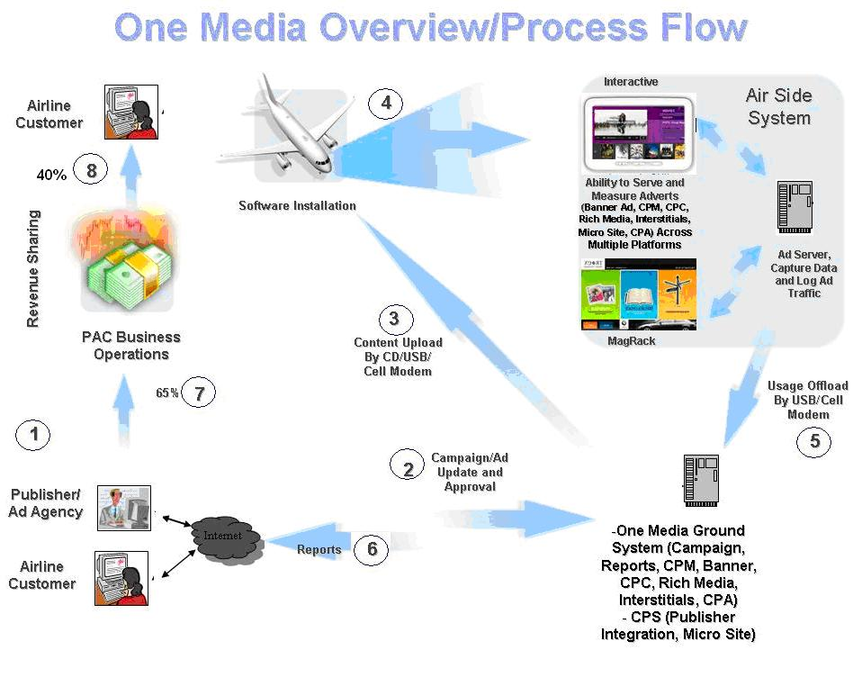
OneMedia provides following formats of advertisements to be served through the interactive:
- Banners (Such as Full, Half, Leaderboard, Skyscraper, and Medium Rectangle)
- Interstitials (Full screen static images of advertisements to be displayed prior to an expected content page or application)
- Micro site (It contains further promotional messages or data relating to the advertisement shown in a given banner.)
- Rich media (It is an online advertising format that utilizes a range of interactive digital media including streaming video and audio.)
OneMedia also provides the Magazine Rack (MagRack) with branded content publications (such as Travel Exchange) through the interactive to enhance passenger experience. By eliminating physical magazines, airline can reduce overhead cost, weight and fuel costs and thus impacting bottom line. OneMedia advertisements are also served through the MagRack within interactive.
OneMedia provides ad-trafficking services where ad campaigns are programmed, delivered, measured and analyzed. OneMedia revenue is shared among publisher/ad agency, airline and PAC. Typical OneMedia revenue share model is 35% to publisher/ad agency, 40% to airline and 25% to PAC.
OneMedia provides the value added service of advertising at a low incremental cost to an airline.

Value Proposition
OneMedia generates ancillary revenue for Panasonic and airline from interactive IFE advertising at a low incremental cost to an airline.
OneMedia leverages the existing web-based ad-sales organizations, networks, processes and procedures.
OneMedia provides convenience and efficiency for “new media” (same ad formats and sizes as internet) by reducing time to market and production cost. OneMedia brings the internet ad format to the IFE.
OneMedia enhances passenger experience by providing branded content and builds more inventory. Inventory is the total number of available impressions which can be sold and delivered. Inventory is also a function of the number of ad placements per page, volume of pages with advertising, refresh rates for displayed advertising on each page, and viewing of content by the audience, in this case the airline passenger.
OneMedia eliminates audience fragmentation by consolidating the passenger reach through network of airlines.

Feature and Functionality
Release 1 – OneMedia Basic
OneMedia Server - Ad serving and logging functionality for airside.
OneMedia Ground Server - Campaign Setup, Upload Creative, Campaign Approval, Reporting, etc.
Banners (Full, Half, Leaderboard, Skyscrapper and Medium Rectangle) advertising format support in the airline interactive. Log Impression (CPM).
- Click through (CPC) support
- To micro site
- To rich media
- To micro site with embedded rich media
- To micro site through rich media
Interstitial – Support full page advertisement while navigating between content page and before launching an application. Log Impression (CPM).
- Click through (CPC) support
- To micro site
- To rich media
- To micro site with embedded rich media
- To micro site through rich media
Rich media - Support Rich media format (15 or 30 second mpeg advertisements prior to movies or via click from Banners/Interstitial). Log Impression (CPM).
- Click through (CPC) support
- To micro site
Micro site – Support multi-page micro site. Log Impression (CPM) as a result of Click (CPC) from Banner, Interstitials and Rich media.
Automated Ad Load Content Update – Enabling update through Communication Manager via cell modem.
Release 2 – OneMedia Enhanced Revenue Advertisement
Capture Passenger Data (CPA) - Capture passenger data (Name, Phone, e-mail address, etc.) from micro site.
Click on Rich media – Enable click (CPC – Cost per click) on Rich media to Micro site. Note; Click on Rich media will not be available when played prior to a movie.
Embedded Rich media – Display Embedded Rich media within a Micro site.
Release 3 – OneMedia /CPT
Content Publishing Tool (CPT) – New Publisher Integration, Content Update, Creation of Micro site.
Applications & Software
On-board OneMedia Server
Advertisement Mangement Tool (AMT)
Content Publishing Tool (CPT)

Part Number and Description
Description | Part Number
OneMedia for Custom Interactive with Revenue Share | PA-PPA0015-007
OneMedia for eXcite Interactive with Revenue Share | PA-PPA0015-008
OneMedia WebEx Training with or without Revenue Share | PA-PPA0015-011
OneMedia for Custom Interactive without Revenue Share | PA-PPA0015-009
OneMedia for eXcite Interactive without Revenue Share | PA-PPA0015-010

Revision History
Revision | Revision Description | Date | Author Name
NEW | Initial Release | 7-June-10 | Rajen Shah

